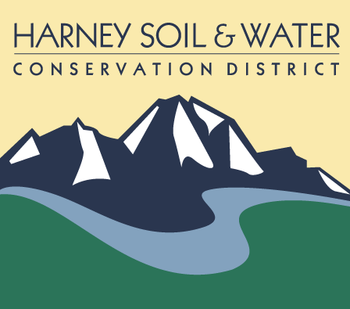
BID PACKET
Wildhorse Medusahead Rye Treatment 2023
August 2023

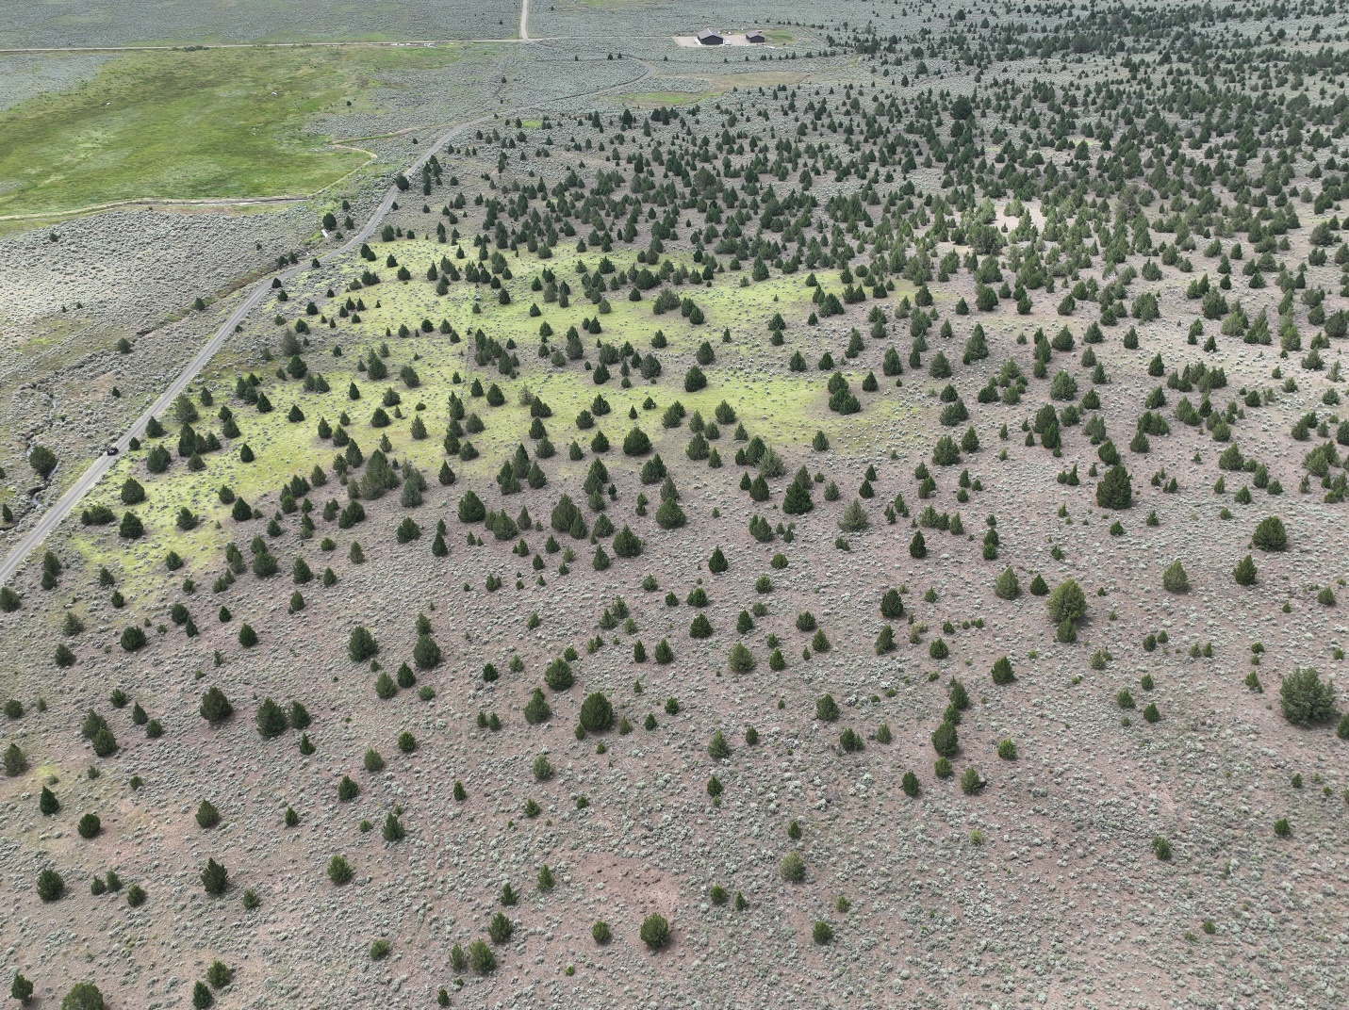

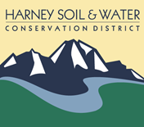
Wildhorse Medusahead Rye Treatment 2023
August 2023

The Wildhorse Medusahead Rye Treatment 2023 is approximately 19 miles north of Fields, Oregon on the East Steens Rd. The Burns BLM has given the Harney CWMA funding to coordinate this project. This funding will be used to aerially apply Plateau at 7oz acre with 1 pint grounded /acres to treat medusahead rye. Approximately, 500 acres is planned to be treated. Project will start around August 15, 2023 and needs to be completed by October 1, 2023.The contractor is responsible for purchasing the herbicide.
These is no bid tour for this project. If, you need more information please contract
Tyler Goss At : (541) 891-0898
Goss@harneyswcd.net
ALL SEALED BIDS (MAILED, HAND DELIVERED OR EMAILED) ARE DUE TO THE HARNEY SOIL AND WATER CONSERVATION OFFICE BY: 12:00 Noon, On August 14, 2023

Contents of bid packet must be returned with bid sheet.

Estimated Start Work Date: August 15, 2023
Contract Completion: All units to be complete by October 1, 2023

