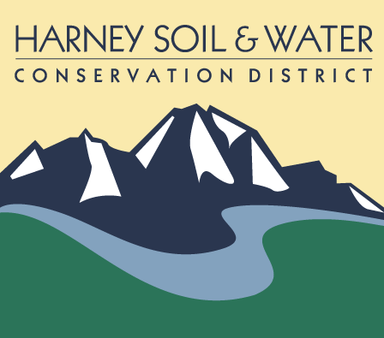
BID PACKET
Burns District BLM Long Hollow/Burke Spring ONAC treatment
June 2023
The Burns District BLM Long Hollow/Burke Spring ONAC treatment is approximately 107 miles south of Burns, Oregon and 5 miles north of Fields, Oregon on Hwy 205 on the Long Hollow Mountain. There is an urgent need to prevent the spread of Scotch Thistle on BLM land. We propose a ground spot herbicide treatment in Upland/riparian. A survey will be performed at the same time using handheld GPS units. There is approximately 619 acres of land to survey on two different sites. The herbicide mix is Clopyralid1 pint/acres at and 2, 4D at 24 oz/Acres + adjuvant for the Scotch Thistle. Burke Springs is a water source; and the contractor will use an aquatic 2,4-D and surfactant. The contractor will supply the herbicide. The treatment will be Mid-June and project must be completed by August 1, 2023.
- Private 40 Acres of Scotch Thistle, Survey 619 acres on two different sites 129 acres on Burke Springs and 490 acres on Long Hollow
- A mandatory bid tour is scheduled for Thursday June 8, 2023
- Expect at least a 4-hour bid tour, meeting at the HSWCD office at 9:30 am

ALL SEALED BIDS (EMAILED, MAILED OR HAND DELIVERED) , ARE DUE TO THE HARNEY SOIL AND WATER CONSERVATION OFFICE BY: Thursday by 12:00 Noon, On June 15, 2023

Contents of bid packet must be returned with bid sheet.

Estimated Start Work Date: June 16, 2023
Contract Completion: All units to be complete by August 1, 2023

