Tips for gardening in extreme heat
June 25, 2021
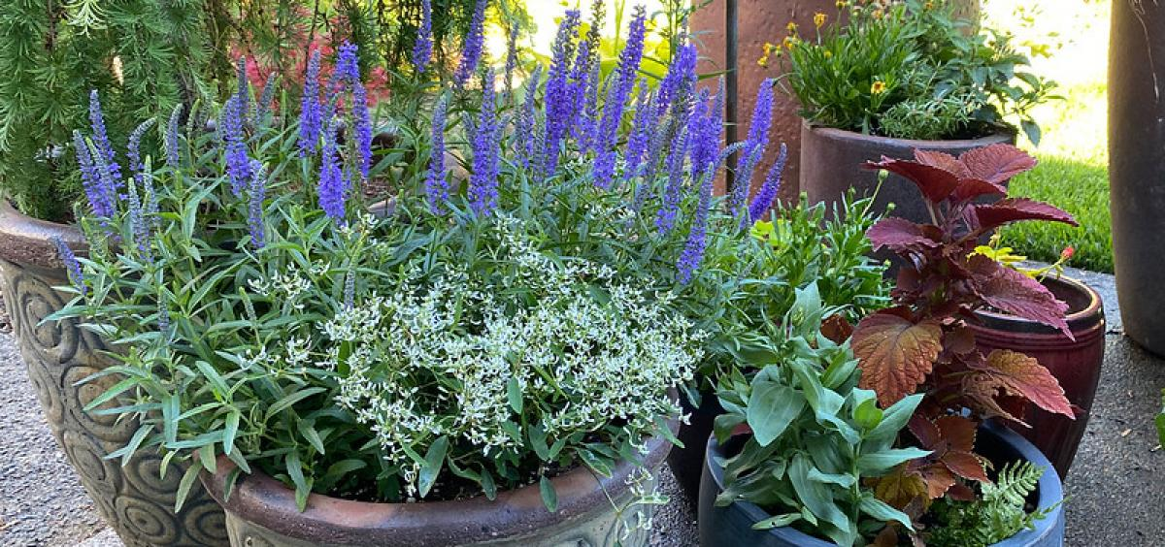
CORVALLIS, Ore. – People and plants need care to make it through the coming heatwave – 111 on Sunday some forecasts say – without wilting.
Erica Chernoh, Oregon State University Extension Service horticulturist, offers some ideas to help keep yourself and your garden as comfortable as possible.
- Keep hydrated. Carry a water bottle – and use it! You need water as much as your plants do.
- If you plan to work in the garden, do it in the morning before the hottest part of the day.
- Wear a hat and lather on the sunscreen when outside.
- Water in the morning to give plants time to take up moisture before the worst heat.
- Water plants deeply, at least to 6 inches down. Plants are the best indicator of when they need water – they wilt. Watch your plants. If they begin to droop, it’s time to get out the hose. Or, dig down in the soil 1 to 2 inches next to the plant to see if it needs moisture. Plants in sandy soil will need to be watered more often than those in clay soil, which retains water much more than sandy soil.
- If you are watering by hand, water close to the soil under the plant.
- Hanging baskets and containers will need to be watered more frequently than those in the ground. Be sure to check them often. Stick your finger in the soil to see when it needs water. If they are small, pick them up. If they are light, water. Consider moving potted plants into a shadier spot during the heat wave.
- Mulch around your plants; it slows down evaporation. You can use straw, compost or decomposed steer manure.
- Use shade cloth, available at garden centers, to shelter particularly precious plants. Rig up some sort of frame and spread the cloth over. Try not to lay it directly on the plants so they have air circulation. The temperature under the shade cloth can be 10 degrees lower. Or, use shade cloth over cold frames, cloches and greenhouses.
- Don’t do anything that will stress a plant, like transplanting, pruning or fertilizing.
- If you’re growing seedlings, move them to a shadier spot.
Tips for the future:
- Grow drought-tolerant plants and group them together.
- Use drip systems and soaker hoses for the most efficient watering. They get the water right to the plant’s roots and avoids excess evaporation.
- Keep the garden well weeded; weeds compete with desired plants for water and nutrients.
- Amend soil with organic material. Well-amended soil holds water better.
About the OSU Extension Service: The Oregon State University Extension Service shares research-based knowledge with people and communities in Oregon’s 36 counties. OSU Extension addresses issues that matter to urban and rural Oregonians. OSU Extension’s partnerships and programs contribute to a healthy, prosperous and sustainable future for Oregon.

