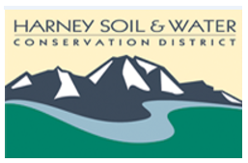
Harney Soil & Water Conservation District
March 26, 2020
Regular Board meeting 3:30 to 5:30 pm
USDA Service Center, Hines, OR
Teleconference only
Teleconference info: 515-603-4915, passcode 633512#
Regular Board Meeting will be audio recorded

Due to the threat of Coronavirus (COVID-19) the March 2020 meeting will be held through Teleconference to allow for the safety of our Board of Directors. However, there will be staff on site for members of the public to attend, we do have heightened screening at our facility.

3:30 pm Welcome and introductions
3:35 pm Approval of minutes: February 6, 2020

NEW BUSINESS
3:40 pm Action Items:
HC Watershed Range Camp Scholarship
Vehicle purchase through MOU
Adding additional check signor
NEPA Docket Number CEQ 2019 0003

OLD BUSINESS
4:00 pm Sage Grouse Database Update
Landowner letter response
Computer/server equipment needs/prices

4:30 pm MONTHLY FINANCIAL REVIEW

5:00 pm Public Comment

5:10 pm Adjourn

