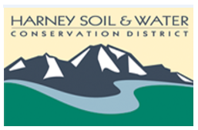
Harney Soil & Water Conservation District
PO Box 848
530 Hwy 20 South, Hines, OR 97738
Phone: 541.573.5010

November 14, 2019
USDA Service Center, Hines, OR
3:30 pm to 5:30 pm

3:30 p.m. Welcome and introductions
3:35 p.m. Approval of minutes: September 26, 2019
3:45 p.m. Old Business: Authority of Delegation
Fiscal review and reports/Quarterly financial report--Review and explanation of the Profit and Loss by Class for July 1 through Nov. to date (20 mins).
Zone 5 update
Status and progress of work plan and open projects (Shannon Brubaker, Sarah Mundy) (40 mins)
Review and discussion of status of ongoing OWEB projects
reported in OGMS , OACD RCPP, Stinkingwater RCPP, BPA Energy, and Ducks Unlimited contract
Review and discussion of progress on the annual work plan
5 pm New business:
Address third signer
Discussions on November meeting.
Surplus property disposition—we currently have nonlockable file cabinets that are old. One has a drawer that is not fully functional. We would like to replace but need guidance as to what to do with old.

