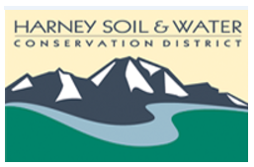
Harney Soil & Water Conservation District
Regular Board meeting
December 5, 2019
USDA Service Center, Hines, OR
3:30 pm to 5:30 pm
Teleconference info: 515-603-4915, passcode 633512#

3:30 p.m. Executive Session:
- Sealed bid for off stream solar livestock watering systems for
water quality and sage-grouse habitat
- Personnel discussion (ORS 192.660)

3:45 p.m. Welcome and introductions
3:50 p.m. Decision from Executive Session
3:55 p.m. Approval of minutes: November 14, 2019
4 p.m. Zone 3 and 5 vacancies
4:10 p.m. Old Business:
  - Policy discussion
    - Action item: Internal Controls & Financial Management
    - Action item: Harassment policy/resolution
  - Action item: CECIL database determination

4:20 p.m. New business:
- SDAO Risk Analysis/policy discussion
- Action item: Audit presentation and review

5 p.m. Project Update
- SIA—Marching Down the Malheur
- Monthly Financials
- Riley Solar Project

5:20 p.m. Public Comments
5:30 p.m. Adjourn

