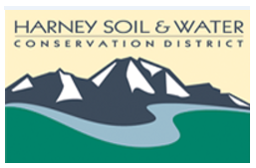
Harney Soil & Water Conservation District
Regular Board meeting
November 14, 2019
USDA Service Center, Hines, OR
3:30 pm to 5:30 pm

3:30 p.m. Welcome and introductions
3:35 p.m. Approval of minutes: September 26, 2019
3:45 p.m. Old Business:
Action item: Delegation of Authority
- Policies Discussion
  - Internal Controls & Financial Management
- Update on Zone 5

4:00 p.m. New business:
• Action item: Line of credit Close-out
• Policies Discussion: Direct deposit/payroll process
- Financial report: Year to date report
- Surplus property disposition (Barbara Pearson & Shannon Brubaker)
  - Potential Purchase request

4:20 p.m. Project Briefing
- SONEC partner report (Carlton Strough)
- Focus Area Action Plan report (Carlton Strough)
- Sage Grouse Status report (Sarah Mundy)
- New Proposal Briefing (Shannon Brubaker & Sarah Mundy)
  - Sage Grouse Addressing the Gaps and FIPIII TA
  - Harney County Water Conservation through Irrigation TA
  - SDAO Safety and Security Cost Share proposal
- All other projects status
  - Report status- OWEB system
  - RCPP’s – Stinkingwater and OACD
  - Ducks Unlimited and other contracts
  - Annual work plan outlook

4:50 p.m. Next meeting discussion: December board meeting (Christmas holiday)
5:15 p.m. Public Comments
5:30 p.m. Adjourn

