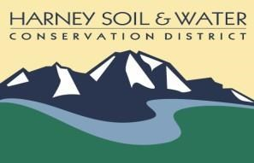
Harney SWCD
Regular Board Meeting
Agenda
August 22, 2019, 3:30 – 5:30 p.m.
USDA Service Center- Hines

3:30 p.m. | Welcome and introductions
3:35 p.m. | Approval of minutes: July 15, 2019, July 25, 2019
3:45 p.m. | Action Items from July 25, 2019  - Follow up on Beaver Table invasive species spray bid, update provided by Guest Speaker Jim Campbell of Harney County Cooperative Weed Management Area
3:55 p.m. | Old Business  - Zola Ryan: Cultural Resource Specialist, NACD Grant  - Subcommittee for Financial policy work group update  - Discussion on Oster Professional Group services
4:15 p.m. | Eric Nusbaum, ODA: Appointment of Zone 5 Member
4:25 p.m. | New Business/Action Items  - Budget  - Resolution for Annual Meeting  - Annual Work Plan Review  - ODA Scope of Work  - Request for Proposal for annual audit
5:15 p.m. | Public comment (2 min ea. -- 10 min total)
5:30 p.m. | Adjourn

