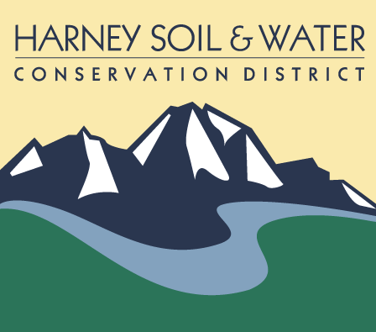
BID PACKET
Falls Fire Hazard Tree Removal
March 2026

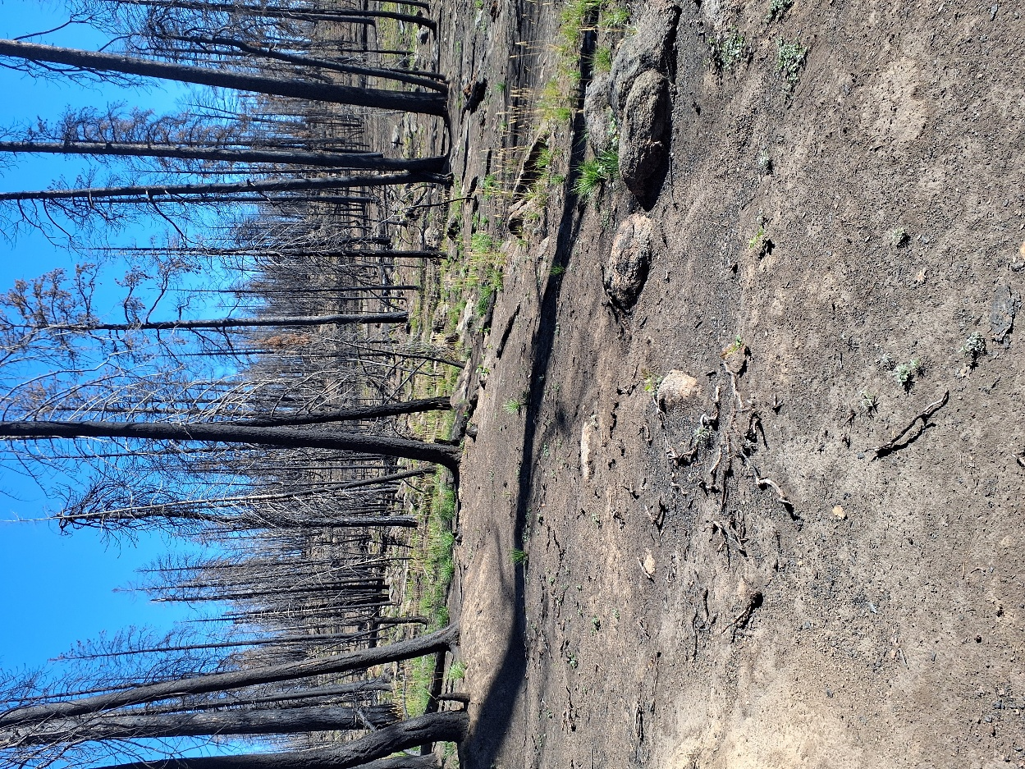

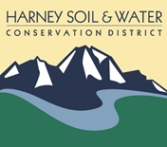
Falls Fire Hazard Tree Removal
March 2026

Hazard tree removal is a crucial step post-wildfire in repairing or reconstructing fence lines within the Bureau of Land Managements (BLM) rangelands. This involves removing dead or dying trees that pose a risk to contractors, ranchers, BLM employees and the public who may be recreating, and checking or repairing fence line. The removal of the trees will also ensure the investment of fence repair and reconstruction is not destroyed. The main concern is to remove all dead or dying conifers that have the potential to strike the fence or people and property working along the fence line.
The attached (Appendix A) Pacific Northwest Post-Fire Tree Assessment Making guide published by the United States Forest Service (FS) in 2021 defines predictors that a tree is likely to die within three years post fire by species. A visual assessment guide is also provided in the guide.
All work within the project area shall be performed using hand crews and power saws only. No heavy equipment or mechanized ground-disturbing equipment shall be permitted.
Project Units and Acreage
Falls Fence Hazard Tree Abatement
• 29 units totaling 196.05 acres
Cutting Specifications:
- Remove all dead or dying conifers within striking distance of the fence line
- All stumps shall be cut no higher than 12 inches above the ground
- All slash from cut or fallen trees within the 12-foot corridor will be scatterer outside the corridor, and not in any ditch, or roadway
- All dead or downed wood within the corridor shall be rolled or carried away from the fence corridor
For Culturally Peeled Tree (CPT), marked and approved for hazard removal:
1.The tree shall be cut eighteen (18) inches above the uppermost extent of the cultural peel scar.
2.Measurement shall be taken vertically along the bole from the highest visible edge of bark removal.
3.The peel scar shall remain intact on the stump.
4.The final cut shall be level and clean, minimizing fiber pull, splitting, or slab tear-out through the scarred section.
5.Cutting below the 18-inch requirement is prohibited unless directed in writing by the Authorized Officer.
If a CPT not previously marked is encountered and determined to present a hazard requiring removal:
1.The tree shall be cut in accordance with the 18-inch-above-peel requirement described above.
2.The location of the CPT shall be recorded using a GPS unit with sub-meter or recreational-grade accuracy (as specified in the contract).
3.GPS data shall include latitude/longitude (WGS84 datum unless otherwise specified), date, and unique tree identifier.
4.The Contractor shall notify the BLM Archaeologist and Authorized Officer within 24 hours of discovery.
5.GPS data and associated documentation shall be submitted to the Authorized Officer within the period of performance.
Definitions:
Dead or Dying: Using Appendix A, any tree that has been damaged by wildfire and has the likelihood of dying in three years. Post bud break for ponderosa pine (PIPO): >70% crown volume killed.
Culturally Peeled Tree (CPT), also referred to as a culturally modified tree (CMT), is a live or dead tree that exhibits bark removal scars resulting from traditional Indigenous bark harvesting practices. These scars were created for cultural, subsistence, medicinal, technological, or ceremonial purposes.
Striking Distance: Defined as target zone of the tree part of concern.
• Within 1x Ht – Target is within striking distance if the trunk or root system fail (distance is the distance of the tree height) for a 80’ PIPO the striking distance is 80 feet.
• Within 1.5 x Ht – Target is within striking distance if the trunk or root system of the tree fails and there are dead or brittle branches that could shatter and fly from the failed tree. Distance in 1.5 x the tree height. If the PIPO is 80’ tall and had large brittle branches the striking distance is 120 feet.
Description of Work:
A mandatory bid tour is scheduled for March 18, 2026.
One representative must be present to be eligible to bid on project.
Bid tour meeting at the HSWCD office at 8:30 am. (office meeting only)
ALL SEALED BIDS (MAILED, HAND DELIVERED, OR EMAILED)(Goss@harneyswcd.net), ARE DUE TO THE HARNEY SOIL AND WATER CONSERVATION OFFICE BY: 12:00 pm, On Wednesday, March 25th, 2026

Contents of bid packet must be returned with bid sheet.

Estimated Start Work Date: April 1, 2026
Contract Completion: All units to be complete by June 15, 2026

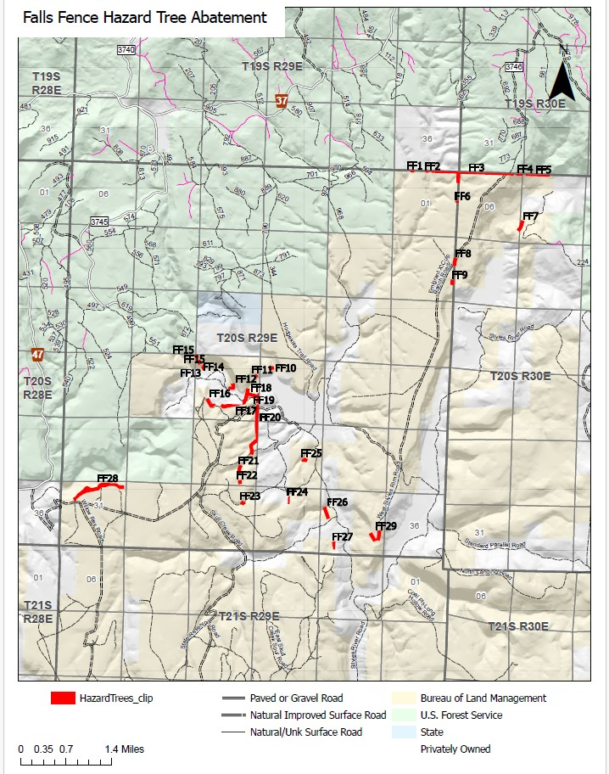
Falls Fence Hazard Tree Abatement
Unit | acres | Bid | Notes
FF1 | 1.14909
FF2 | 0.991102
FF3 | 28.5269
FF4 | 1.94509
FF5 | 6.58249
FF6 | 1.00279
FF7 | 6.42003
FF8 | 4.39473
FF9 | 3.06907
FF10 | 2.81148
FF11 | 1.82253
FF12 | 4.99304
FF13 | 2.25558
FF14 | 2.49704
FF15 | 2.09908
FF16 | 6.19934
FF17 | 8.44121
FF18 | 16.6252
FF19 | 1.57458
FF20 | 24.1859
FF21 | 4.95586
FF22 | 2.3667
FF23 | 2.40764
FF24 | 2.0732
FF25 | 3.06616
FF26 | 6.9023
FF27 | 3.27954
FF28 | 32.594
FF29 | 10.8169
Total Acres | 196.048572
