Irrigation Ditch Pilot Program Application
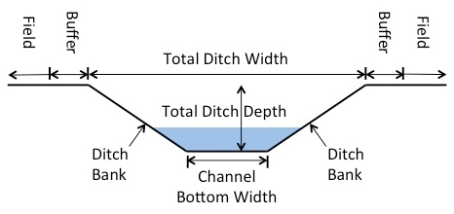
____________________________________________________
This is a pilot program to assist landowners in cleaning ditches in Fall 2024 and Fall 2025 along the Silvies River and Poison Creek floodplain. Identify ditches to clean by vegetation removal, bank reshaping, blowout fixes, sediment removal and elevation restructuring. Looking to work specifically in irrigation ditches.
Project will require a few site visits by Harney Soil and Water Conservation District Staff and High Desert Partnership to survey ditch if you are a candidate for the program. Project will be reviewed by OWRD watermaster and Harney Basin Wetlands Collaborative.

How applications will it be ranked:
- Priority will be given to projects that cross property lines and involve multiple landowners on the application that are associated to the ditch and agree on the project scope.
- Priority to projects that fall on exempt work of ditch maintenance under DSL Removal/Fill permit rules.*
- Water rights needed for irrigated land by ditch to estimate value to flooded wet meadows.
- Projects which OWRD deems as important for water movement.
- Ranking will be done through the Harney Basin Wetlands Collaborative
- If project is determined it needs a Removal/Fill permits and landowners are willing to pursue a permit, work can begin in 2024 to start that process for hopeful Fall 2025 start date. * Talk to SWCD staff about permit process and what it entails if landowner would like to move forward.
- Culverts associated with the ditch maintenance could be replaced with in-kind sizes if deemed necessary for ditch function.

*Department of State lands Chapter 141, Division 85, 0530 Exemptions for Certain Actives and structures section (4)

Ditch Cleaning Pilot program
Contact SWCD for more information on the program # (541)-573-6446 ex 4
Note: more landowners associated with the same ditch cleaning improve project feasibility
- Contact Information
Primary Applicant (please print):_________________________________
Phone Number: ____________________ Email: ________________________________
Address: __________________________________________________________________
- Irrigation Ditch information
Tax lot #: ___________ , _____________ , _____________ , _____________ , _____________ ,
Ditch Name (if any): _________________
Does it go dry during the not irrigation season? YES or NO
What needs to be done on the ditch (circle which is applicable)
Set ditch bottom Elevation | Fix ditch dimensions | Clean out sediment in ditch | Fix blowout | Clean out Vegetation | Other

- Current dimensions use figure to provide information in feet
Estimated Ditch Length to be worked on: ft or miles_______________
Top Ditch Width:_________________________ Total Ditch Depth:______________________
Channel Bottom Width: ______________________
Ditch bank state Raise over Run if any ____________________
- Culverts
Any culverts o off the ditch? Any other ditches branching off identified ditch
Yes No Yes NO
Are they buried in sediment | Are they sitting too high? | Are they sitting at right height?

Beginning point___________________________________ End Point_____________________________
Estimated Irrigated acres by ditch ______________________________________________
Signature__________________________________ Date: _______________________

Co-applicants: Print ___________________________ Sign_______________________

Print ___________________________ Sign_______________________

Print ___________________________ Sign_______________________

